‘Immunization Timetable’ Ref IAPCOI July 2012: MODIFIED
Age and further schedule will change if any vaccine taken late, most vaccines are preferably should be taken; some vaccines need not give lifelong protection. Many people tend to avoid costly vaccines and multiple injections on a day, but that is not recommended. Rotavirus vaccine cannot be started after age 5 months. Two vaccines if not given on same day will have a gap of 1 month. Insist on weight height and milestones check at each vaccine related visit.
Age (completed weeks/months/years)  Due Date | Vaccines | Given date | Wt/Ht/  milestone
Birth | BCG, OPV 0, Hep-B 0
6 weeks  EASYSIX PREVENAR ROTARIX  8 DISEASES 2 INJECTIONS | DTwP 1/DTaP 1, Hep-B 1, Hib 1,IPV 1, Rotavirus 1,PCV 1
10 weeks  EASYSIX PREVENAR ROTARIX | DTwP 2/DTaP 2,Hib 2,Hep B 2, IPV 2, Rotavirus 2,PCV 2
14 weeks  EASY SIX PREVENAR | DTwP 3/DTaP 3,Hib 3,Hep B 3, IPV 3, PCV 3
6 months
This visit also important to check milestones
9 months completion  TRESIVAC/PRIORIX | OPV 2, MMR  {no OPV with plan B C)
11 Months TCV TYPHOID | TCV TYPHOID
12 months  Haverix JUNIOR | Hep-A 1
15/16/17 months  3 injections= tresivac,varilrix, prevenar | MMR 1,Varicella 1,PCV booster
16/18 months  EASY SIX BOOSTER | Booster 1: DTwP B1/DTaP B1,IPV B1,Hib B1
18/24 months  HAVERIX JUNIOR 2 | Hep-A 2 {6 monthd after first dose}
2 years  TCV TYPHOID | Typhoid *
4 ½ to 5 years  EASY SIX/Boostrix,tresivac,varilrix,TCV TYPHOID *, OPV | DTwP B2/DTaP B2,OPV 3,MMR 2,Varicella 2  Typhoid *
10 to 12 years  BOOSTRIX, GARDESAL | Tdap/Td:  HPV
IAP recommended vaccines for High-risk* children (Vaccines under special circumstances):
1-Influenza Vaccine,2-Meningococcal Vaccine,3-Japanese Encephalitis Vaccine,4-Cholera Vaccine,5-Rabies Vaccine,6-Yellow Fever Vaccine,7-Pneumococcal Polysaccharide vaccine (PPSV 23)
* High-risk category of Children:{including epidemics}
• Congenital or acquired immunodeficiency (including HIV infection),
• Chronic cardiac, pulmonary (including asthma if treated with prolonged high-dose oral corticosteroids), hematologic, renal (including nephritic syndrome), liver disease and diabetes mellitus
• Children on long term steroids, salicylates, immunosuppressive or radiation therapy
• Diabetes mellitus, Cerebrospinal fluid leak, Cochlear implant, Malignancies,
• Children with functional/ anatomic asplenia/ hyposplenia

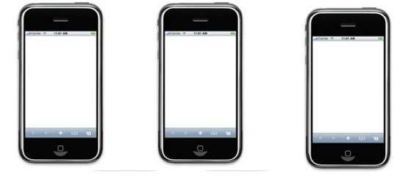
Immunize babyname date-of-birth
Send a sms to 566778
Get free reminder sms ON MOBILE
FREE VACCINATION DATE REMINDER SERVICE PROVIDED BY IAP COI
FOR MORE DETAILS, VACCINATION SERVICES, CENTRES,DOSES, COSTS
whatsappDR KONDEKAR 9869405747
Immunize raani 23-12-2011

